# How to change your RideshareOnline.com email address

1. Login to [RideshareOnline.com](https://rideshareonline.icarpool.com/en/Login.aspx)
2. Go to profile and select My Account

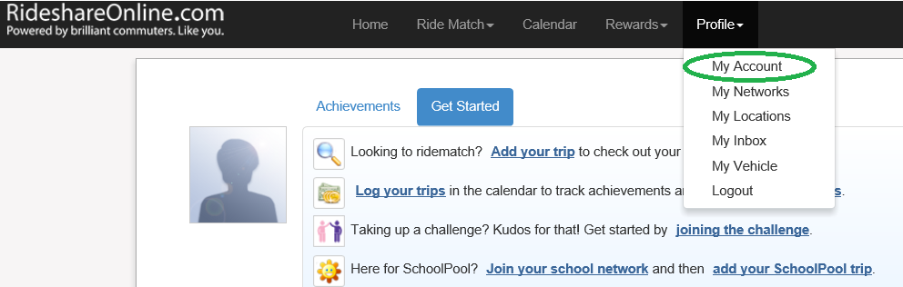

1. Scroll to the bottom of the page and select “Change Email Address”

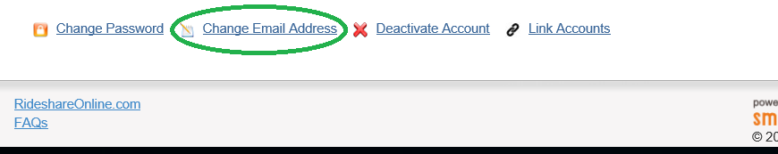

1. Fill out the form and then respond to the validation email. You **must** use your email address that begins with you WSDOT account name. This is the same user name you sign into your computer with.